Step one: Inside the Github repository, click on the Forest Observatory Ontology.owl

Step two: copy the ontology content

Step two: copy the ontology content

Step three: paste it into a new Notepad (or any text editor of your choice), then save as anyname.rdf in your local disk and change save as type to All Files

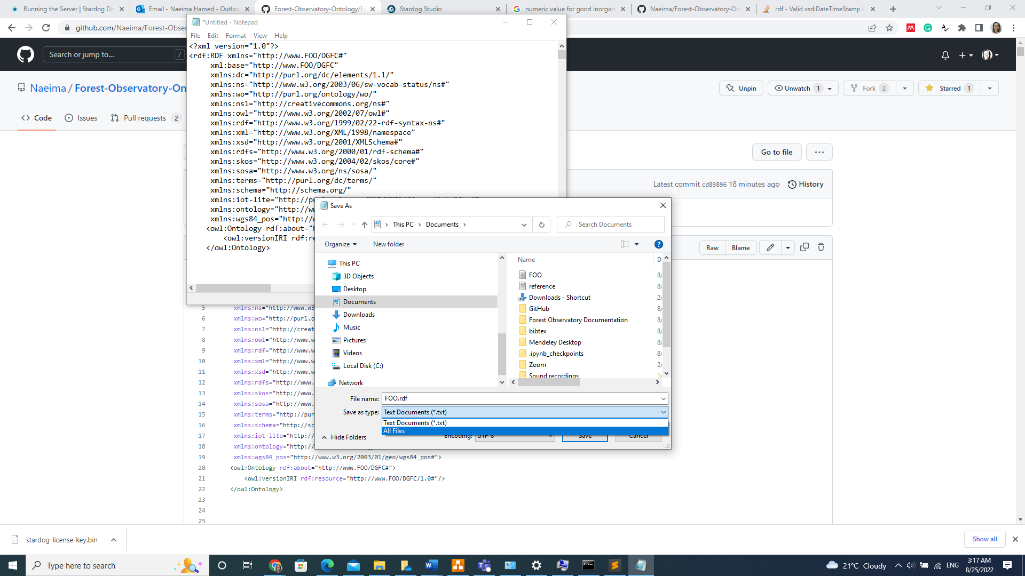

Step four: load the ontology to a knowledge graph platform- creating a new triple store ). This example uses Stardog studio. https://stardog.studio/

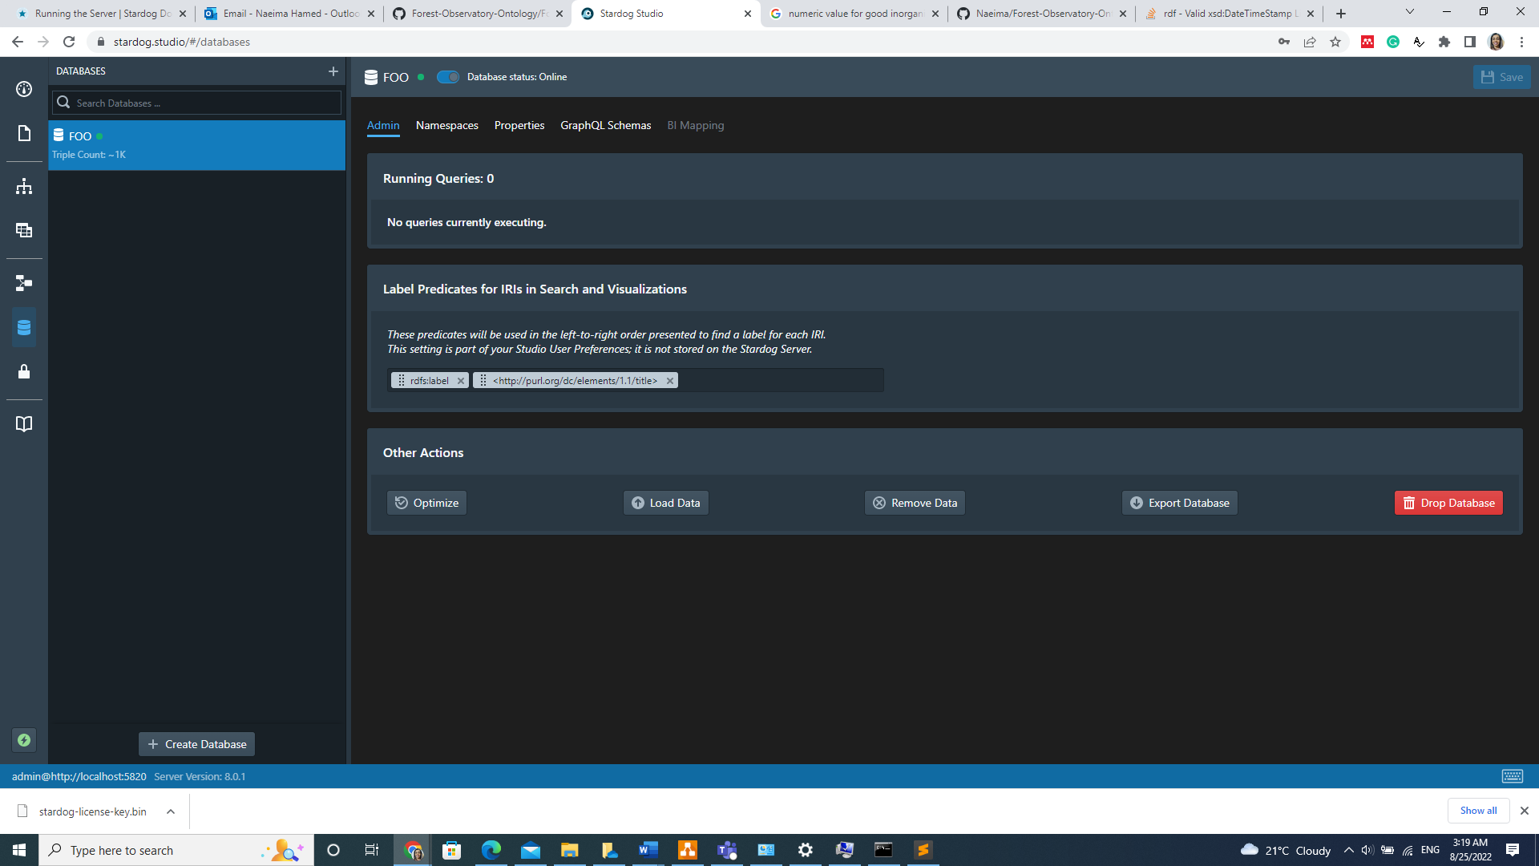

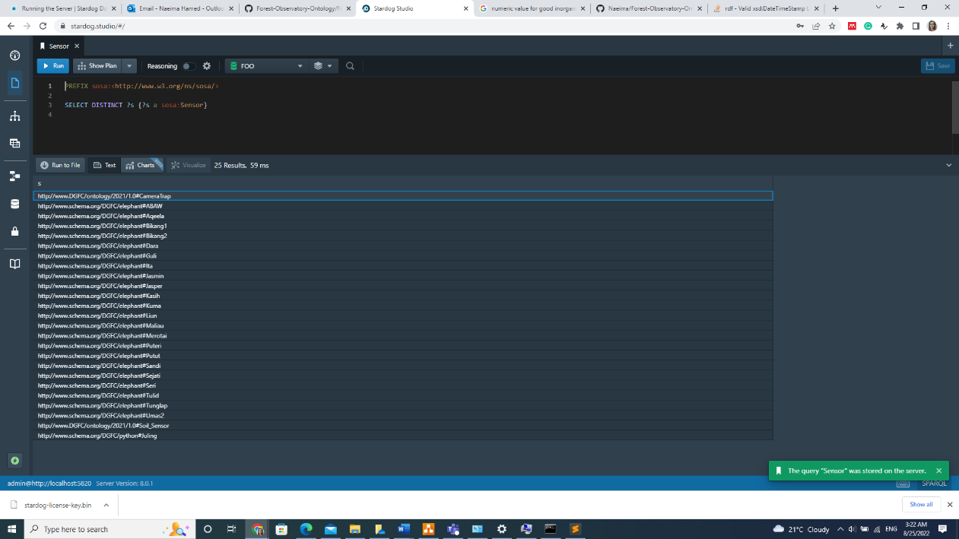

Step five: querying the ontology

Step five: querying the ontology

Step six: Add dataset to FOO database as Turtle format

